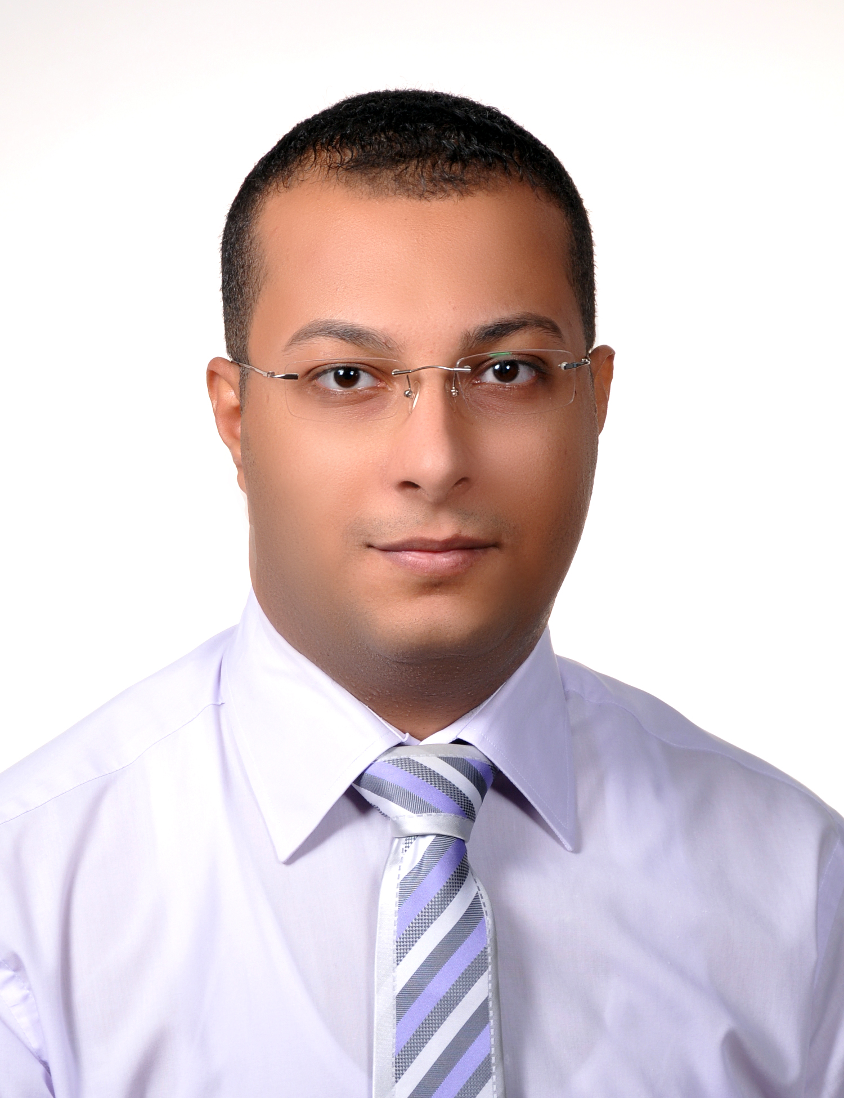
BISHOY GUIRGUIS SHAFIK
Objective :
- Seeking a challenging and responsible position to use my abilities and experience effectively and efficiently for children and I also have acquisition for learning and developing new skills.
Personal details :
- Date of birth : September 9, 1984 - Gender : Male
- Nationality : Egyptian - Marital Status: married.
- Passport No :A11152714 - Passport Issue Date: 2021

- Driving License : UAE D/L
Academic Qualifications :
- Bachelor's degree in Commerce, 2005 Sohag University, Egypt.
Language : Arabic " Mother tongue " *English "Good "
Computer skills :
- ICDL Certificate. - Windows "XP , Vista , 7 " .
- IT. -Internet.
- Microsoft Office (Word – Access – Excel – PowerPoint).
Experience :

Work as Accountant & Public relations officer in contracting company in Emirates (Nov2008—Until Now).

ACCOUNTANT

Follow-up expenses of the company

Continue downloading expenses to cost centers

Experience in payables and payroll processing, and general ledger entries.

Preparing monthly reports for each project.

Follow-up employees' salaries and to hold them to cost centers.

Follow-up materials disbursed from the stores and directed to projects

Follow-up work of sub-contractors and preparing cheque to the suppliers.

Preparing and distributing stuff salary.

Follow-up materials purchased and addressed directly to the projects

Preparing monthly reports for each project.

Work by Peachtree accounting program.

Al-Ain , Abu Dhabi , UAE
Mob : - 00971507004616 - Email: besho_222@yahoo.com

2) Public relation officer

Follow-up all transactions in government departments such as the municipality ,the Ministry of Labor , the Department of Naturalisation , Residency, identity and health insurance .

Extracting all building permits and demolition contracting companies .

Extraction and renewal of all business licenses .

extract work permits and workers.

extraction and renewal of labor card ,residence, identity cards and card health insurance for employees.

3) Training in Office financial auditor (July 2005--Aug2008).

Preparing production reports & Stock reports of finished goods and raw Material

Preparing all the statement including weekly and monthly due of customers and commission statement of salesman according to company policy.

Preparing finical statement on monthly schedule when request.

Prepare the details and reports of the daily assignment

Well experience in account receivable, account payable, payroll and preparing all kind of accounting vouchers.

Preparing the daily reports to management and finance manager which includes daily fund following, production sallies and other activates of company.

Updating all kinds of data entry to software and maintain records.

Preparing trail balance.

Analyzing financial statements and giving comments regarding company financial situation.
PERSONAL Specification :
- Team worker skills, good oriented.
- Have the ability to work under pressure.
- Sociable.
- Dynamic.
- Professional in creating good relations with all Nationalities.
- Have the ability to handle all problems and how to penetrate it and find a good solution to be satisfied to everyone.

In The End
Thanks for your time, and I want to be one of your team. I'm looking forward to meeting you for your personal interview as soon as possible.

THANKS FOR YOUR INTERESTING

